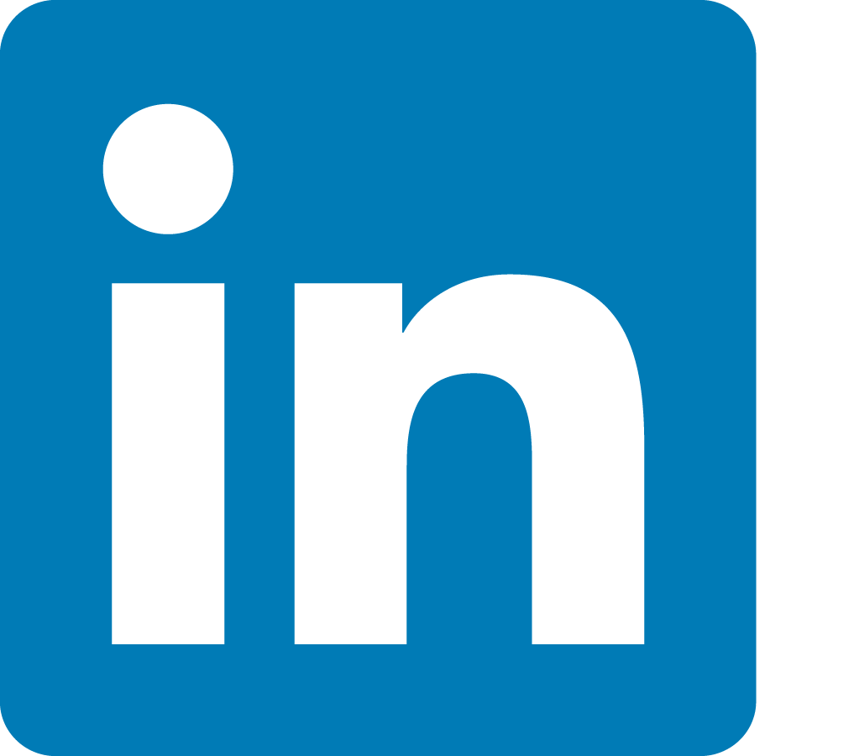
Building & Maintaining a
LinkedIn® Profile
LinkedIn is the world’s largest professional online networking platform, and it is extremely important for job seekers in any industry to take advantage of the many perks this website has to offer.

Benefits of a LinkedIn Profile
LinkedIn often seems foreign for people who are not familiar with the website. Many job seekers either have a LinkedIn profile but do not actively use it, or they do not have one at all. The main function of LinkedIn is networking, and the site serves as a constant job fair of sorts because you are always in contact with working professionals, job seekers and employers who are looking to hire. Since 85% of jobs are filled through networking, it is crucial to use LinkedIn as often as possible when seeking gainful employment.
Simple ways to use LinkedIn:
- Put your LinkedIn profile URL in the header of your resume
- Connect with fellow job seekers at job fairs & other networking events
- Strengthen existing professional relationships
- Reconnect with former co-workers & colleagues
- Expand job searching
- Create a space to house your ‘digital resume’
- Follow companies for job updates
- Follow organizations within a specific industry
- Stay up-to-date with industry trends & terminology

LinkedIn Terminology
Connection: This is a person on LinkedIn who is in your professional network, and typically someone who knows you. This means that the two of you agreed to accept one another into each other’s networks. Think of a LinkedIn connection like a ‘friend’ on Facebook.
Invitation: This is the beginning of every relationship on LinkedIn. You are inviting someone to become one of your connections and a part of your network. Think of an invitation like a ‘friend request’ on Facebook.
Network: This is the entirety of your connections on your LinkedIn account. It is important to grow and maintain your network of professional contacts and to keep them in mind as you navigate the website.
Creating & Editing your LinkedIn Profile
First and foremost, LinkedIn is a way for professionals to network with their colleagues, but it is also a useful self-marketing tool, especially for job seekers. Your LinkedIn profile needs to highlight your personal value to anyone who might be looking. A vast majority of users on LinkedIn display information about their companies or organizations they belong to, and bringing attention to the work you do with others is important. However, it is not the only thing that matters on a LinkedIn profile. The main focus should be on the experience you bring to the table, outside of any organization you might work for or with.
When someone views your profile they will likely be thinking, “What’s in it for me?” Be sure to create and edit your profile so it truly highlights the value you hold as a well-rounded, employable person.
As you move through the different sections of your profile, you will see all of the different ways you can emphasize your brightest qualities as a job candidate.
- Name: Full name, no nicknames (nicknames like Nick for Nicholas are fine)

- Profile Picture: A professional headshot is the best option for your LinkedIn profile. Headshots taken on a sophisticated smart phone camera are fine, but it is recommended to put in the extra effort and get a professional headshot photo. Many users will make a snap judgment of your profile picture when deciding if they wish to view the rest of the page, so you want to have something that looks clean, natural and inviting.
  - Headshot should take up a majority of the frame
  - Professionally dressed or dressed in clothing you would wear in your workplace
  - No pictures in casual dress, ‘selfies’, pictures with family, friends, pets, etc.

- Banner Photo: The banner or the cover photograph at the top of your profile is an area where many users choose to put their company logo, which is acceptable; however, your profile should ideally be all about you. Your banner photo should relate to your ‘professional brand’ – the things that set you apart from other people in your industry or that can you do incredibly well. Some examples are a picture of server board or computers for an IT professional, or classrooms and textbooks for teachers. Pexels.com is a great website where you can download free stock photos for this purpose.

- Professional Headline: This is an absolutely vital area for your LinkedIn profile, and it is another point of snap judgment when other users are browsing the page to decide if they want to see more. Remember, you want your profile to be benefits-oriented and to display the value you offer, so you DO NOT want to just highlight that you are looking for work in this section. Many LinkedIn users will use this section to list something like ‘Seeking new opportunities’ or ‘In-between opportunities,’ which is also discouraged. Avoid any headline phrasing where you are not presenting definitive value to another user. The best information to put here is a concise statement or set of keywords describing your professional self. This can be a potential job position or industry you are looking to break into, areas in which you are a subject-matter expert or another brief tagline for users to get a good idea of what you have to offer. Avoid using industry nicknames like ‘IT Whiz’ or ‘Truck Driving Extraordinaire’ and keep it professional!

- About/Bio: This section is a chance to take your professional headline and expand on it. You can make another big first impression with users who are looking at your profile, because this section gives them a better idea of what you do as a professional. Some key aspects to note are:
  - Use industry specific keywords (300,000 LinkedIn users search by industry)
  - List the location(s) you work or have worked in
  - Keep the section to about 2-3 paragraphs of text
  - The first paragraph should be the most enticing in order to capture users’ interest and draw them in to the rest of your profile
The number one thing to keep in mind with this section is to keep it short and simple. Do not recap your entire life narrative here, because the purpose of the About section is to bring users like recruiters and hiring managers into your inbox. If they receive all of the information before talking to you directly, then they might not feel the need to contact you at all. This may be the difference between just another curious employer and a solid job lead or even an interview.

- Experience: This section is the ‘meat’ of your profile and the main area that LinkedIn users spend time looking at. The Experience section of your profile will function in a similar manner to your resume, but it works a bit differently. On a resume, common wisdom says that you need to be concise and tailor it to the specific job you are applying for. You need to stick to the past 10-15 years of work experience while only including the most relevant experience for the job, and there is rarely room to expand on the details of your previous work.

The Experience section on LinkedIn does not have these restrictions. First of all, a virtual profile does not have the time constraints of a recruiter or hiring manager who is looking at a paper resume, so you can get into more detail with your job responsibilities at each role. Additionally, it is encouraged that you include the full range of your work experience because it depicts a cohesive narrative, a story of how you got to where you are today. For example, if you are looking for work in healthcare, perhaps your first few jobs were in a customer service-heavy field like hospitality or the food industry, and that led you to a desire to help other people in your career. Users enjoy seeing how your overall work experience followed a path and helped you progress over time.

  - TIP! – LinkedIn does not have a built in feature to add bullet points, but a good workaround is to open a Microsoft Word document (or any other word processing software) to copy a bullet point from there and copy it into your profile

- Education: Generally, your highest level of education is the only item you need to list, but listing all of your education is also acceptable. Just keep in mind that you should only include educational degrees, certifications or licenses that are completed or in progress. Anything that is no longer in use should be omitted.

- Volunteer Experience: Community service and volunteer work can be music to a recruiter’s ears, so make sure you list all of your past or current volunteer experiences.

- Skills & Endorsements: This is another hotspot area on your profile, where connections can validate the skills that you list on your LinkedIn profile for others to see through endorsements. When a connection clicks on a skill, your profile will publicly display that they ‘endorsed’ it – think of it as social proof that yes, you are capable of that skill. As more people begin to endorse you, you will see your top three highest endorsed skills appear in this section. It is imperative to have at least five technical skills that are directly related to your career field…the more the better! Be sure to also include any soft skills you have in this section. Pressing the ‘Show more’ drop down arrow will display the rest of your skills, which are broken down into the following sections:
  - Industry Knowledge
  - Tools & Technologies
  - Interpersonal Skills
  - Other Skills
You are able to pin certain skills that you want to show up at the start of the section, but it is advised to have the top three skills appear first on your profile, since these are likely the areas in which your peers find you most proficient. Endorse your other connections on a few of their skills, and they will often return the favor!
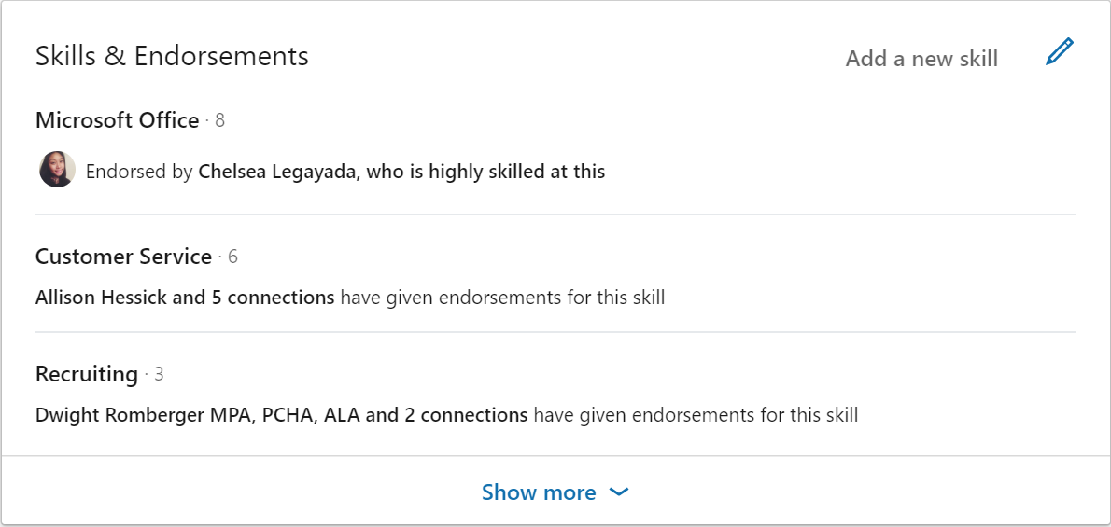
- Recommendations: Connections can also provide endorsements of your abilities by writing a recommendation on your profile. Recommendations can serve as another point of interest on your profile because they give users a further sense of your value through the testimonials of people in your LinkedIn network. You are required to approve any recommendation written by one of your connections before it publicly appears on your profile. In addition, praises that you write for other users will also appear on your profile.
Write recommendations for your former colleagues because, just like endorsements, they might return the favor. The one distinction you need to remember, however, is the fact that these are written testimonials to your work ethic and abilities, so you want them to feel genuine. It is best to allow recommendations to come naturally, rather than to directly ask your connections to write them.

- Interests: The interests section is a helpful tool that will populate your homepage feed with industry information, company information, job postings, and more. Whenever you follow a company you work for or are interested in, or join any groups related to your industry, LinkedIn will show relevant results in your news feed.

- Other Important Tools: All of these tools are located at the top of your profile.

  - Add profile section: The default sections listed above cannot be removed from your LinkedIn profile, but you can always add more to enhance it. If you have a specific area of your professional background that you wish to highlight (like any special projects or awards, for example) the Add profile section tool will be helpful.
  - Edit public profile & URL: While there are some privacy tools in this section, the main reason you want to use this is to edit the URL of your LinkedIn profile. When you first make your profile, the account URL will look something like: www.linkedin.com/in/YOUR-NAME - 123456789. Since you want to put the profile URL on your resume, you do not want those random numbers at the backend of your link. Use this tool to edit it down to: www.linkedin.com/in/YOURNAME instead to look more professional.
  - Add profile in another language: Another great feature of LinkedIn is the ability to recreate your profile in a language other than English. If you are bilingual and applying to bilingual job positions, then this will be extremely helpful! You can list your English-speaking URL on your resume as well as the URL linked to the profile that is displayed in your language of choice.

Navigating LinkedIn
Every time you log into LinkedIn you will be taken to the homepage, which is fairly easy to navigate and contains features that will help enrich your LinkedIn networking experience even more!
- LinkedIn Button & Search Bar: In the top left-hand corner of the homepage, you will see a LinkedIn symbol next to a search bar. The symbol serves as a ‘home’ button to redirect you from any page you might be on. The search bar acts like any other search bar, allowing you to look up other users, companies, hashtags and more.

- The LinkedIn Taskbar: The taskbar, located to the right of the search bar, functions as a directory for the other important sections of the website, such as networking and job searching. Below are the different areas listed in the taskbar.

  - Home: Just like the LinkedIn button, this will bring you back to the homepage.
  - My Network: Here you can view any connection requests as well as potential connections that the LinkedIn algorithm suggests for you based on your work history, education and people you may know. LinkedIn will also provide you with professional groups, companies and hashtags it thinks you might want to follow.
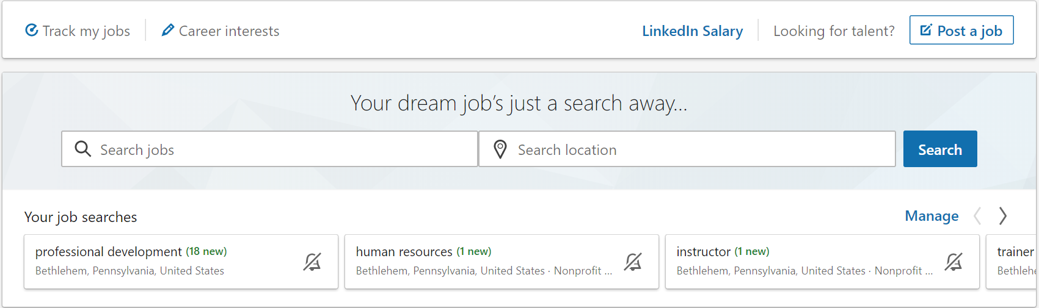
  - Jobs: There are over 20 million jobs posted on LinkedIn, and growing! Employers are increasingly moving their postings from other sites to LinkedIn because they believe they can get better applicants from the platform. For this reason, using LinkedIn’s job search function is a must, and it will change and evolve as you use it more frequently. LinkedIn tracks the work history and education of your connections so when you look at a job, you will see connections who have worked or currently work at that company; it will also note the factors you have in common with them (e.g. an alum of the same college or a former coworker). This is a crucial piece of the LinkedIn networking puzzle, since it has the potential to give you more authentic job leads through your connections than you would otherwise get from using sites like Indeed or Monster.

  - Messaging: LinkedIn has its own messaging service just like many other social media platforms, and you can access it both in the taskbar and toward the bottom right corner of the screen. A good rule of thumb when writing a LinkedIn message is to think of it as somewhere between a text message and an email. Your message should not be as casual as a text message, since LinkedIn is used for professional purposes, but it does not need to be as formal or structured as an email, either. Typically, a polite initial greeting will suffice and direct replies work well after that. Another thing to remember is that LinkedIn operates on ‘Internet time,’ which essentially means that replies to messages should not be ignored for longer than a few hours or a day at the most. Unlike an email, where a few days is not unheard of for a reply, messages should be answered promptly, just like you would on other social media sites.
  - Notifications: Checking your notifications tab will become a regular occurrence as you begin to use LinkedIn more frequently. This tab will give you a few different types of notifications. First and foremost, LinkedIn will show you (to a certain extent) of who is viewing your profile. This can be helpful information if you are applying to jobs on LinkedIn and you begin to see more people looking at your profile, maybe even users who work at the companies you applied to. LinkedIn will also notify you of new job postings that are similar to those you have already applied to, trending news stories and life updates when one of your connections has a birthday or starts a new job.
  - Me: This section includes a link to your public profile, account information and settings, a record of your posts and activity on the website and a help forum for questions about LinkedIn.

- Profile Box: Underneath the task bar, on the left hand side of the home screen you will see a box with your name, headline and basic tracking information. Clicking on your name or profile picture is a shortcut that brings you directly to your profile. The tracking information will be covered later on in this handout.

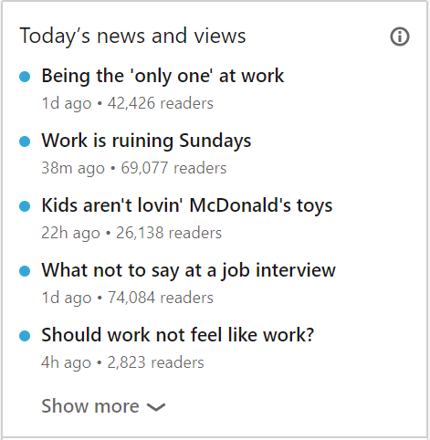
- Start a post & write an article on LinkedIn: Right in the center of the home page is the box where you can write posts, share professionally relevant photographs, videos or documents and write your own articles using LinkedIn’s article writing service (similar to writing a Facebook status or note). It is important to share frequently on LinkedIn so you can get your name out there and drive more traffic to your profile during the job search. In addition, posting often is the easiest way to make yourself visible to connections who might be able to help you find a position.

- Today’s news and views: To the right of the posting box, you will see a number of news stories currently trending on LinkedIn. Clicking any of these stories will present you with an editor’s overview of the article in question and the editor’s picks for insights from other LinkedIn members sharing the article on their pages.

Tracking Statistics & Tools
Like any other social networking site, LinkedIn is all about getting people to view your page, especially during the job search. Understanding how the website’s tracking information works can not only help you know if employers are looking at your profile, but also how you should update your profile in the future.
When you update your profile in a significant way, share insights on an article or are otherwise active on the platform, you should see an increase in viewership. LinkedIn will track this information for you via the Your Dashboard section on your profile. This dashboard is not a part of your public profile and will only be seen by you.
On the dashboard, there are three main pieces of tracking data to pay attention to:
- Who viewed your profile – LinkedIn users who directly viewed your profile
- Post views – Views on anything you have shared or written
- Search appearances – The number of times you have come up in a search. This can include someone searching you by name, title, industry, area, etc. Clicking on each of these numbers will show more detailed information. While you cannot view everyone who has looked at your profile or posts without paying for LinkedIn’s Premium service, you can gain just enough insight for the free data to be beneficial. You can see trends in viewership (pictured below) and where users who viewed your profile are working.
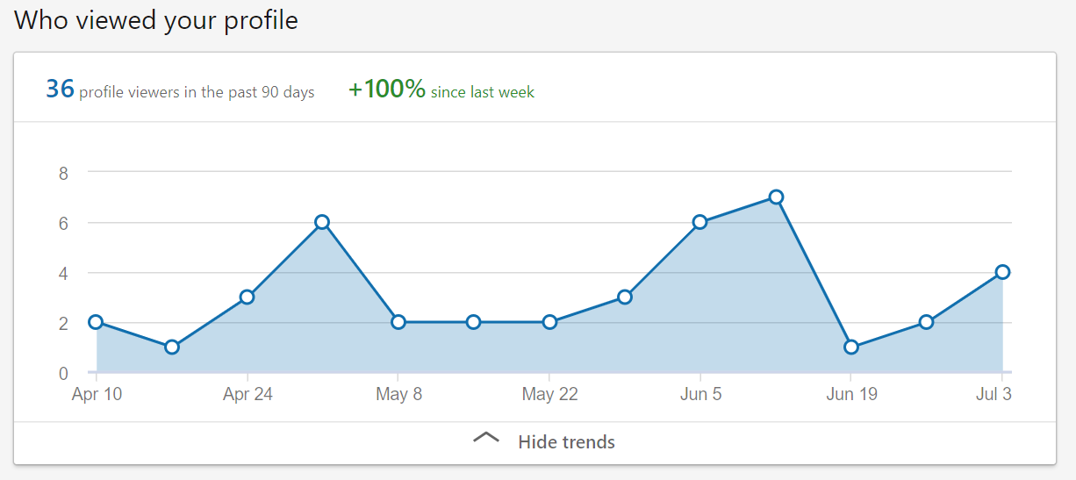

Growing Your Online Network
Connections
Since LinkedIn’s primary purpose is networking, you should be interacting and connecting with other users on the website as often as possible. This includes current and former coworkers, professional colleagues, individuals you may meet at job fairs and more.
Some of the users you interact with on LinkedIn may not be people you are directly connected to at the moment, but whom you may want to connect with in the future as your career goals progress. LinkedIn will let you know what kind of ‘investigative’ work you may need to do by way of connection degrees. Next to each person’s name on LinkedIn, you will see one of four numbers: 1st, 2nd, 3rd, and 3rd+. These markers indicate how close this person is to you through mutual connections you share.
- 1st Degree Connections: People you are directly connected with
- 2nd Degree Connections: People who are connected to your 1st degree connections
- 3rd Degree Connections: People who are connected to your 2nd degree connections
- 3rd+ Degree Connections: So on and so forth…
Why do these labels matter? What investigative work do you have to do when fielding connections on LinkedIn? Let’s find out.
Let’s say you apply for a job on LinkedIn. On most job listings, the job poster will have their profile attached to the job description. You read over the person’s profile and see a ‘2nd’ next to their name. That means that the person who posted the job (and could potentially hire you!) knows someone you know. This is where you begin some of that investigative work by finding out which one of your connections knows them so you can reach out to that person; they could help push your resume forward to a recruiter or even get you in ahead of time for an interview. As stated earlier, 85 percent of jobs are filled through networking, so a good portion of your job hunt should be spent reaching out to your circle on LinkedIn and offline. Recruiters and hiring managers are much more likely to hire someone if a coworker or colleague of theirs gives them a personal recommendation.
Be vigilant when browsing LinkedIn, because you never know what kind of influencers or employers might know people within your network!
Nurturing Relationships on LinkedIn
While you want to use your connections for their networks while job searching, you do not want to make this the first thing you say to them or the only reason you interact with them. Only using connections to take advantage of their networks does not look good on your part and could result in some snags in your job search. You should always aim to nurture relationships with your connections in an authentic and natural way. Here are a few tips:
- Send a personalized invitation message when asking someone to join your network that highlights why you want to connect with them (remember: DO NOT ask for anything in this message)
- Send a welcome message once someone has accepted an invitation from you, thanking them for accepting your invitation
- Post valuable content consistently (content that displays your industry insights & knowledge)
- Like a connection’s ‘trigger events’ such as:
  - A new job
  - Work anniversary
  - Completion of education or training
  - Posts or articles
- Introduce connections to one another if you believe they would benefit from a meeting
While you never want to directly ask for anything at the beginning of a professional relationship, you should always keep the objective of the relationship in mind, especially if you are interacting with someone who can connect you to the right people and help you find job leads

LinkedIn Etiquette
LinkedIn is a professional website, and there is an expectation of how members should behave that is worlds away from the casual, ‘anything goes’ nature of Twitter or Facebook. There are certain topics and manners of speaking you should avoid in posts or discussions. Follow this table for an overview of what you should and should not do while using LinkedIn.
What to do | What not to do
Post professionally relevant content | Post anything inappropriate or otherwise irrelevant
Post thoughtful, relevant content | Post negative content complaining about a workplace or job hunt
Speak in a generally positive way | Use slang words or offensive language
Avoid controversial subjects (politics, religion, etc.) | Engage in public arguments of any kind
Professionally relevant content can consist of:
- Articles discussing an industry or workplace culture
- Personal insights on different aspects of your career
- Anything related to your work or volunteer experience

Final Helpful Tips
- Download the LinkedIn app to easily access the site on a mobile device like a smartphone
- Update your profile on a regular basis, at least weekly
- Do not accept every connection request sent your way (unless you personally know them or think it would be beneficial to add them to your network)
- The best times to post content to gather the most views are Tuesday-Thursday between eight and nine a.m., and between four and six p.m. (local time)
- After you apply for a job on LinkedIn, look at the job poster’s profile. They will receive a notification that you viewed their page and your name will already be on their radar!

Facts & Statistics
- There are over 630 million professionals on LinkedIn
- 90 million users are in senior level positions & 63 million are in decision-making positions
- Fully optimized LinkedIn profiles (or profiles with the ‘All-Star’ rating) are 40 times more likely to receive job opportunities
- LinkedIn profiles with professional headshots receive 14 times more profile views
- A study in which 24,570 fictitious resumes were submitted to entry, mid & senior level positions found that resumes with a comprehensive LinkedIn profile attached to them received nearly twice the amount of callbacks from recruiters than those with bare or nonexistent LinkedIn profiles
- Profiles with more than one work experience will be viewed up to 29 more times than if they only had once position
- Articles with titles between 40-49 characters perform the best, and articles without a video perform better than those with one
- Longer posts that are split into five, seven or nine headings perform the best
- Motivated was the most overused word on LinkedIn in 2014 and 2015
- There are 80 million monthly active users on LinkedIn
More than 90% of recruiters use LinkedIn!!!

