How to Sign In to your Typing.com Account
*Please note: This “how-to” applies to those people who have already created a Typing.com account. If you have not created one yet, please watch the video above*
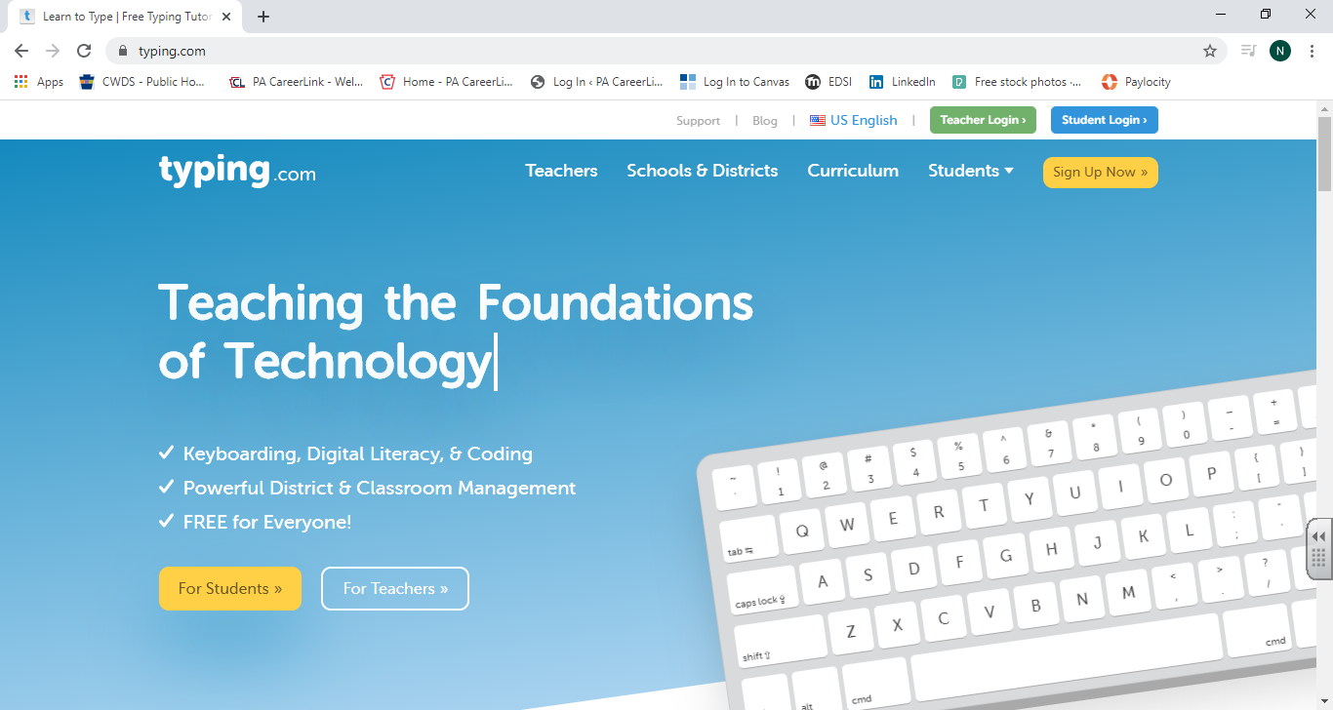
- Go to Typing.com using any web browser (Microsoft Edge/Google Chrome/Safari/Firefox/etc.):

- Click on, “Student Login” in the top, right hand corner:

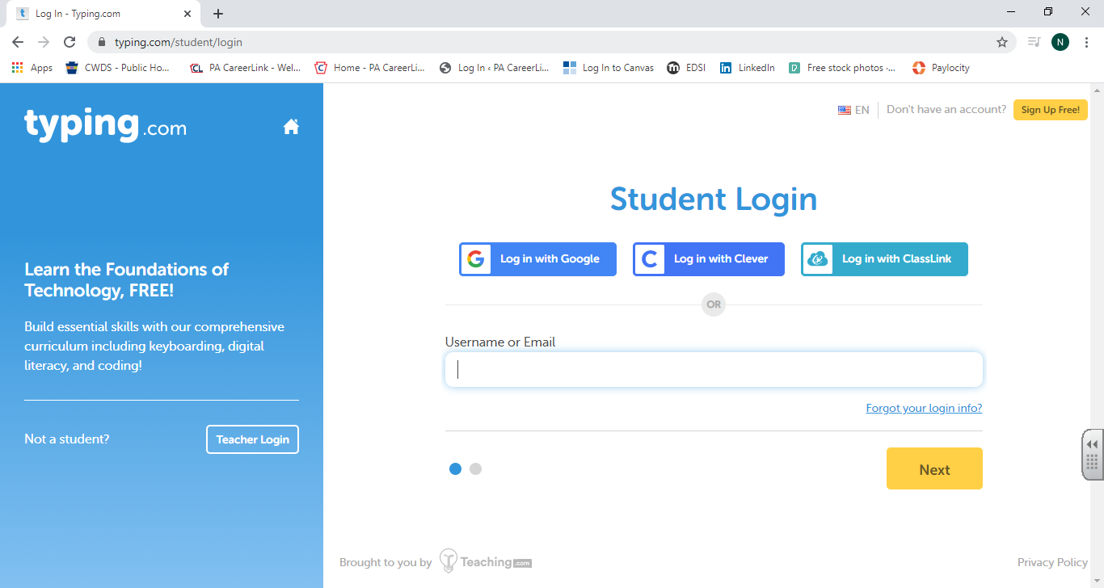
- Type in your Username, then click on “Next” (or email) in the text box (if you forgot your Username then please use the, “Forgot your login info?” option right below the text box):

- Type in your password in the text box, then click on “Next” (if you forget your password, please use the, “Forgot your login info?” option as previously mentioned):
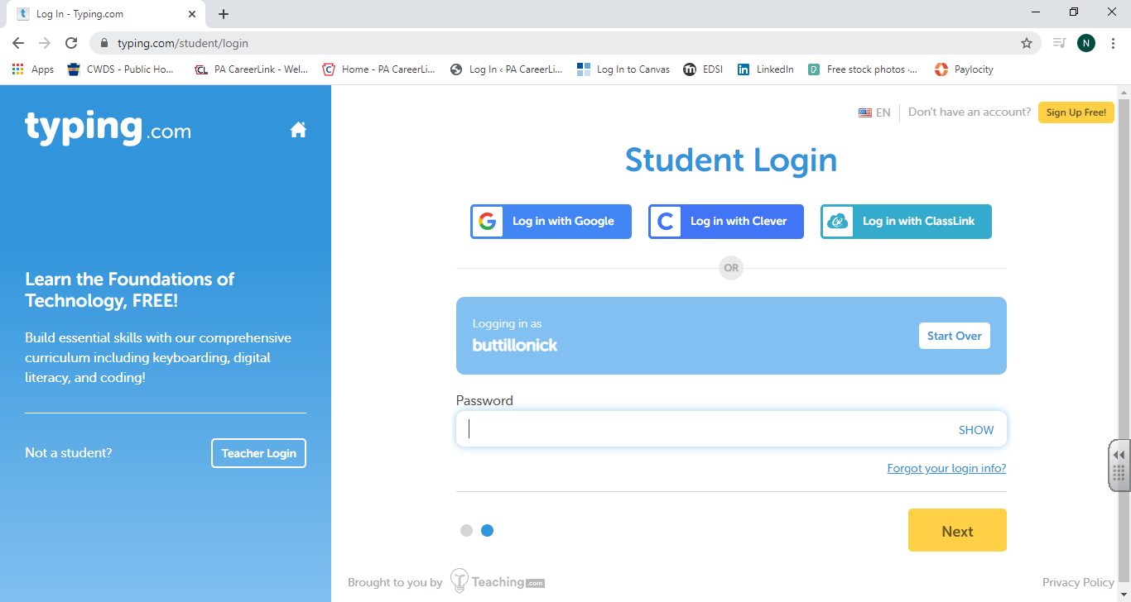

After that, you will be logged in and can continue typing!

