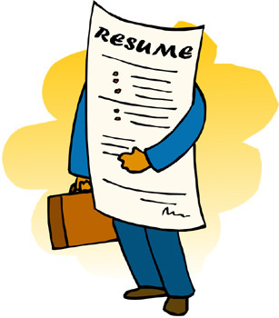
Job Search for the Mature Worker
Resume Writing Tips
What type of resume should I use?
- Chronological
  - Most common type of resume. Lists work experience first in reverse chronological order (most recent job first). This type of resume is best used if you have a consistent, stable work history and intend on staying in the same field.
- Functional
  - A more flexible resume format. Focuses on skills and experiences relevant to a position, over work history. This type of resume is best used if you are changing career fields or if you have gaps in your work history.
- Combination
  - A good mix of the chronological and functional resume formats. The top of a combination resume emphasizes the skills (functional) while the bottom lists your work history (chronological). This type of resume might be a good option to use if have recently been laid off from a position you have worked for most of your career.
Should I type my own or use a template?
Generally it is wiser to type one from scratch. While templates can be helpful with formatting and used as a guideline, templates will set off Applicant Tracking Systems (ATS). These applicant tracking systems are programs recruiters use to scan through resumes at large companies. If an ATS is confused by a resume template, then it will not let that resume through to human eyes, so it is best to avoid templates when drafting up a resume.
Is there anything that should not go on my resume?
Yes, do not put down your height, weight, date of birth, marital status, sex, race, social security number or any other unnecessary personal information. Do not include a picture of yourself. Do not include salary or benefit expectations. Also do not include your references. References should be readily available for any interview, but not attached to your resume. Write down your references on a separate sheet with the same heading at the top as your resume.

Please see the back of this section for resume examples!
Top 10 tips for resume writing:
- Limit your work history. Employers are only concerned with the past ten years of work experience as it relates to the position you’re applying to. Leave older, unrelated jobs off of your resume.
- Don’t include graduation dates. For any degrees or certifications you may have, dates are unnecessary. Simply put the degree and the field of study. If you have a Bachelor’s degree or anything above, then listing a high school degree or G.E.D. is not necessary.
- Be careful about listing years. Be cautious about the language you use to describe your experience or work history. Avoid statements akin to, “Offering 25 years of experience”. This will flag you as a mature worker and may be a turn off for an employer. Instead use “10+ or 15+ years of experience” to talk about your skills and former positions.
- Avoid using “I” or “My”. With your name at the top of the page in your header, it is assumed all of the work experience and skills belong to you, hence saying “I” or “my” is unnecessary.
- Customize your resume for each position. Every different position you apply to should have its own resume for it. It’s ok to have versions of your resume serve as templates (for different industries, for example), but you should still tailor your resume to the job description.
- Shoot to have your resume be 1 page in length. Recruiters and hiring managers spend about 7 seconds on average looking at an individual resume, so there is no need for anything longer than one page. Two pages, however, is acceptable.
- Tweak your details according to the position. If you have experience in management/higher level roles, and you’re applying for a role with less responsibilities, then you should reword some of your prior work experience to better match the new position’s tasks.
- Include keywords from the job description. Applicant Tracking Systems are used by larger companies to scan through resumes, searching for keywords to push forward matching resumes to human eyes. Be sure to read through the job description and put those keywords on your resume.
- Highlight your connectivity. Show employers that you are up to date with need-to-know software and the rest of the modern world. Include relevant knowledge of the latest programs on your resume. Listing your LinkedIn profile will also show you’re connected.
- Be prepared to email/upload your resume. Practically all of your job applications will be online through sites like Indeed.com or directly through company websites, so make sure you know how to attach your resume to an email or upload it to a website without losing your formatting.

Cover Letters
What is a cover letter?
While a resume serves as a list of you qualifications and work experience, a cover letter is a tool to convey this information in an expanded and more personal format. A cover letter is essentially your resume verbalized according to your unique character.
Can I use a template for a cover letter?
Recruiters and hiring managers read through hundreds of cover letters, so you do not want something that is too ‘cookie-cutter’. Your cover letters should stand out from the applicant crowd. Cover letters should also be tailored to each job you are applying to. It is ok to find a particular style, format and work experiences you like using, but be sure each new job has a new cover letter.
What goes in a cover letter?
A cover letter should include carefully chosen anecdotes from your professional experience which demonstrate to a recruiter/hiring manager how you will be able to add value to their company.
Specifically, here are the most important details necessary for any cover letter:
- How your work experience meets the job requirements
- How your skills meet the job requirements
- Why you want to join an organization
How should I begin the writing process?
Before you actually begin to write a cover letter, be sure you have read over the job description and produced a resume matching it. After those tasks are completed, ask yourself the following questions to brainstorm content for your letter:
- What attracted you to this job?
- What excites you about this company?
- What kind of person is the company looking for?
- What experiences do you have that demonstrate you can do the job?
- If hired, how would you add value to the company?
- Why are you the best fit for this job?

***If you are having difficulties answering these questions, then you might want to reconsider applying for the position***
Please see the back of this section for a cover letter example
Sample Cover Letter
Robert Jobsearcher
1200 Job Searching Avenue
Allentown, PA 18104
Cell: (610) 456-7890
robert.jobsearcher@gmail.com
June 25, 2020
Typical Recruiters Inc.
1900 Employer Street
Allentown, PA 18104

Dear Hiring Manager,
My name is Robert Jobsearcher, and I bring five years of office management experience with professionalism and precision. Recently, I came across an opening for an Administrative Assistant position through your job posting on Indeed.com. After reviewing the job description, this position seems to be a great match for my experience and skills. I hope to bring my innovative abilities to this position.
I possess a great talent for innovation which I have demonstrated in my work with Hager Staffing Firm LLC. At Hager, I served as an administrative assistant and was tasked with updating the company’s database and file management system. After reviewing the way the database had operated, I decided it was best to simplify the information in order to make it easier for staff to read by building a new database spreadsheet and transferring the records from the antiquated database. The newer sheet allowed recruiters and staffing managers to more easily pull client and candidate information for their differing tasks. The firm was able to increase candidate placement by 25% in the six months following the implementation of the new system due to reduced downtime searching for information and client satisfaction increased by 20% during the same time, as well.
I am confident my inventive skills and professional background will allow me to help grow your business, should I be considered for employment. I would be excited for the opportunity to discuss this position further. Please feel free to reach me at robert.jobsearcher@gmail.com or (610) 456-7890. Thank you for reading my letter.
Best,
Robert Jobsearcher

The Interview Process
Before the door:
- Research the company. Go to the company’s website and read through all of it. Know their mission statement and values inside and out. Know the most recent news surrounding the company.
- Pack your pad-folio. Bring at least 5 copies of your resume, any relevant work materials that might come in handy during the resume and 5 copies of your references just in case.
- Dress professionally. If you have not updated your wardrobe for a while, it is time to go out a buy a new ‘interview uniform’. Look the part of the modern employee!
- Practice your body language. Walk tall, practice making eye contact with others, smile, and practice your handshake. It should be a firm handshake – neither a wet noodle nor a vice grip.
The Interview:
- The interview begins the moment you are on the company’s property.
- Be polite and courteous to everyone you see, especially the administrative assistants and janitors.
- Be sure to smile and show enthusiasm throughout the interview process.
- Exude confidence when speaking to the interviewers. Speaking confidently will relay your energy and excitement for the position.
- Show your interviewers you have the experience necessary and can hit the ground sprinting.
- Let the interview team know you are up to date with the latest relevant technologies and the world of social media (if you are, never embellish in your interview).
- In less formal parts of the interview – be sure to mention active hobbies like running, weight-lifting, dancing, etc. to demonstrate your vigor and vitality (Do not lie about hobbies. Pick some new ones up if you don’t have any to talk about!).
- At the conclusion of the interview, be sure to ask questions to display your level of interest in the company and the position.
- Be sure to ask the interviewers what are the next steps in the interview process/when you can expect a decision.
- Thank every interviewer for their time and be sure to ask for a business card from each of them to send an appropriate thank you email.
- Thank the front desk on your way out, plus anyone else on the way who led you in the door.

After the Interview:
- Send a thank you email to each person who interviewed you within 24 hours of the interview. Note – each email should be specific to the person.
- Wait for the next steps/their decision. Be sure to respect the time-frame they have given you. It is likely they are interviewing other candidates for the same position, so they will need time to finish interviews and make an appropriate decision.
- Continue your job search! No matter how strongly you feel about an interview, you never know when there might be someone just as good as you whom the company prefers. Don’t put all of your eggs in one basket and keep applying.
Writing an Appropriate Thank You Email
- Subject line: Thank You – [POSITION TITLE] Interview
- Dear [INTERVIEWER’S NAME]
- Thank the interviewer for their time and consideration
- Express how pleasant the interview was
- Let them know you felt it was an extremely valuable experience
- If the interview team took you on a tour of the facility/office, be sure to specifically thank them for that as well
- Remind the interviewer of your skills and how you would make a great match for the position
- If there were multiple interviewers, be sure to bring up something specific you spoke about with each one
- Thank them one last time, tell them you look forward to hearing their decision, and offer the ability to reach out to you should they have any further questions.
Please see the back of this section for a thank you email example
SAMPLE THANK YOU EMAIL
SUBJECT LINE: Thank You – Administrative Assistant Interview
BODY OF THE EMAIL:
Dear [INTERVIEWER’S NAME],
Thank you for taking the time to interview me for the Administrative Assistant position at your company. I really enjoyed our conversation. It was especially pleasant to hear about your personal growth at the company.
This position seems to be a great match for my skills and interests. As I mentioned this morning, I possess great organizational skills which I hope to bring to this position.
Thank you again for the time and consideration. Please feel free to reach out to me if you need any more information.
Have a great day!
Best,
Robert Jobsearcher

10 Tough Interview Questions
These are some questions you may be asked in your interviews. Not all of these questions are specifically age-related, but could be a way for an employer to get some information about your age out of you. Use these questions to help quell negative expectations employers may have about mature workers and prove your value.
- Tell me about yourself. Keep your answer brief and professionally orientated. This is not the time to bring up any personal hobbies you have or your relationships with your family. The employer is asking about your professional background, so keep it professional. Discuss your experience, but avoid talking about your ‘years of experience’. Emphasize a positive and energetic outlook.
- Why are you looking for a job? Your answer should be straightforward and simple. Be honest, but not negative. For example, if you were let go from your previous position due to a mass layoff, then a great answer would be, “My company was forced to downsize, but I left on great terms with management”. Layoffs and unexpected decisions happen, so honesty is always the best policy.
- You haven’t worked in a long time. Why not? Again, honesty is the best policy, but be sure to emphasize transferable skills and tasks that kept you busy in your down time. If the gap in your work history was for a medical reason, explain that and reassure the interviewer everything is settled with. If you needed to take care of a family member, discuss any relevant skills like managing complex financial issues, which you learned to do during that time. If you just have not found a job since leaving or being let go from a previous one, tell the interviewer about classes and volunteer opportunities you have been partaking in to keep yourself busy and informed. The same can be said for those of you who retired and then realized retirement wasn’t for you.
- What are you looking for? Be specific. It will take a lot of personal time to come to your appropriate answer to this question. Be prepared to name the type of job you want and how your skills will translate to this new employer.
- Can you keep up with the current programs/software we are using? This question is likely going to pop up more often for workers 55+ than any other segment of the labor force. Answer this question by talking about projects you have worked on which use those current technologies or classes you have been taking to keep yourself up to date.
- What is your biggest weakness? This question is a chance to brag about your skills, if you answer it correctly. The interviewer is looking for you to be honest with your shortcomings (since we all have them), but also to discuss how you are actively working to improve yourself. For, example if your biggest weakness is time management, then you can talk about how you have been investing more time into scheduling and utilizing your time to the best of your abilities. Avoid cliché responses like, “I work too hard” or “I’m a perfectionist”. As the interviewer will be expecting these answers. Set yourself apart from the crowd with this question and use it to show your worth.
- What are your salary requirements? Arm yourself with knowledge to best answer this one. Use sites like Salary.com and Glassdoor.com to know what someone in your position should be making. Establish a bottom line and produce a range using the information you have learned. An informed salary range will impress the interviewer because it will show them you took the time to research. If you are interviewing for a position that you are overqualified for, then make sure you are ok with a possible reduction in pay compared to your last position. P.S. Only an interviewer should bring this question up!
- How would you handle working for someone who is less experienced? Express you are someone who is always striving to grow. Tell the interviewer you would be excited by the opportunity to learn from someone who will teach you things you may not know.
- How do you think you’ll fit in with the company culture? This question is likely to come up if you are applying for a position at a company with a higher amount of younger employees. This question can best be avoided by understanding the type of company you would be walking into before you go into the interview, however, this question can come up regardless. The best way to answer this question is to emphasize you flexibility and eagerness. Just like the previous question, demonstrate you would be excited to grow with the company and help expand its culture. Also express that you believe your personality is a great match for the company’s culture.
- Why are you looking for a change after XX years? If you are switching roles after being in the same position for a long period of time, then the interviewer may have some concerns. Use this question to establish loyalty and value to the interviewer. Be honest with the reasons you may have moved on from a previous role, but with a little je ne sais quoi. Explain you really enjoyed your previous role, but are prepared for a new and exciting challenge. Talk about the successes you had at your previous role, but be sure to frame it in a way where the interviewer could see those successes at their company.

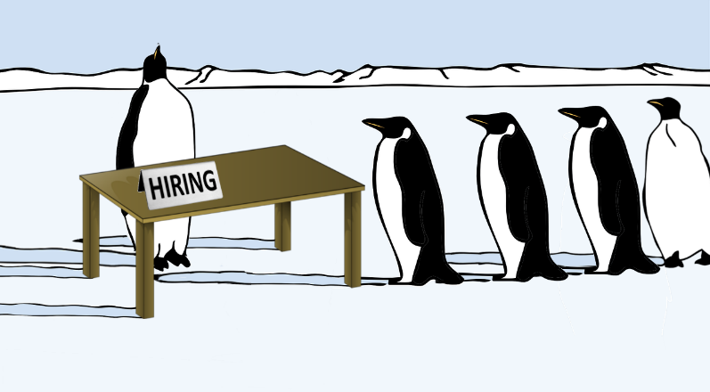

Helpful Websites
- www.gmail.com
  - The standard email for any job seeker. Gmail is user friendly and easily accessible. If you do not have an email for your job searching needs or simply need a new one, then Gmail is the way to go.
- www.typing.com
  - A great website to practice using a keyboard. This site offers free lessons, tests and games all provided to help fine tune your typing skills. You can register for an account free of charge, so you are able to save your progress.
- www.gcflearnfree.org
  - A great website to use for help with many relevant technologies and tools. This site is great for help with the Microsoft Office tools. It offers guides on Word, Excel, PowerPoint and Access.
  - Use the specific links below for some of the bigger topics.
    - https://edu.gcfglobal.org/en/topics/office2016/
    - https://edu.gcfglobal.org/en/topics/computers/
    - https://edu.gcfglobal.org/en/topics/onlinesafety/
  - This site also has lessons in computer basics, online best practices, job searching tips, and many more great topics.
  - When going through the lessons on this site, click the little printer icon to start each section. See below:
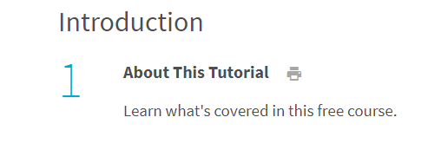
- www.indeed.com
- www.monster.com
- www.glassdoor.com
- www.salary.com

