**Keyboarding**

How to use a mouse

The computer mouse allows you to move freely across the screen using the cursor (pointer). ‘Clicking’ the mouse will allow you to start programs, open up menu and options tabs or begin writing in a particular spot on a word document, for example. All desktop computers come with a mouse, and you can use a mouse on a laptop computer if you do not like the touchpad built into it.

Invented in 1963 by Douglas Engelbart, the computer mouse has developed over the years and now comes in a variety of designs. It’s called a ‘mouse’ because it has a basic mouse shape and the cable that attaches it to the computer looks like a tail. When referring to the device in the plural, both ‘mice’ and ‘mouses’ are acceptable, according to the Oxford English Dictionary.

Mice were first made with two gear wheels to define direction and then with a ‘trackball’, all of which moved in contact with a surface. Today optical mice that use light to detect direction are more common. Mice can also be wireless or cordless, making them easier to move.

**Follow these step-by-step instructions to help you get to know your mouse**

**Step #1:** Pick up your mouse and have a look at it.

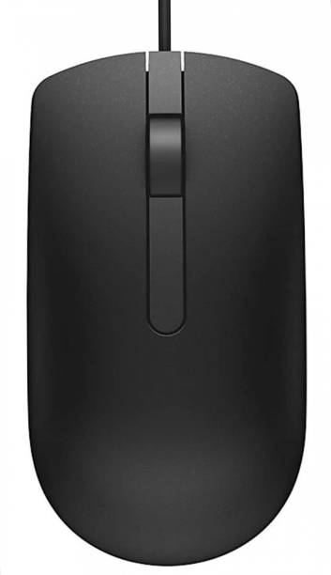 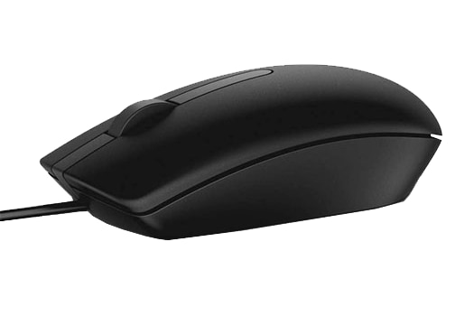

At the front of the mouse (which points away from you), there are two buttons – Left click and Right click. You press, or ‘click’ these buttons to make things happen. These buttons will do different things on the computer, independently of one another, but we will get into that later.

Most mice have a wheel in between these buttons to move the screen up and down. This action is called, “scrolling”.

**Step #2:** Learn how to hold your mouse comfortably. It is normally held between your thumb and fingers as shown, with your index finger and middle finger resting on the left and right click buttons.

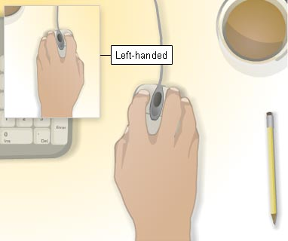

**Step #3:** Try clicking. Use your index finger to click the left button.

Left-handed users can use the mouse as imaged above, plus there are options available to change on your computer, which allow you to swap what the buttons on your mouse do.

**Step #4:** Try a double-click. This is done quite often using the left mouse button. You have to click twice in a row, as quickly as possible. The first click tells the computer that you are in a particular ‘window’ (or space on the computer), and the second click tells the computer you are selecting a button/link/program/etc. to do something in that window. If you double-click too slowly, then the computer will think you are just clicking once again and again, and will not perform the action.

**Step #5:** It’s time to practice. We are going to practice double-clicking on the website: <https://www.letsgolearn.com/bubble.html>. To reach this site, hover over the icon that looks like this and double-click it:

This is known as a shortcut. A shortcut is a link to a website that goes directly on your desktop. Double-clicking the shortcut will automatically send you into a web browser. The same will go for any link you may come across on a website or word document. A link will look like this, where the website link is underlined and highlighted blue. When you hover over a link, your cursor will turn into a little hand. This is how you know clicking this link will take you to a website.

**Step #6:** Now let’s try a right click. Right click wherever you want on the page. A menu will appear giving you different options. This menu will be different depending on what program or window you are in. To get rid of this menu, simply left click anywhere else in the window.

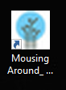**Step #7:** Let’s try some more practice. Find the shortcut below for <http://pclibrary.org/mousing/mousercise.htm>? and double-click it:

***Follow the game until you get the maze mini-game, then close your browser***

How to use a keyboard

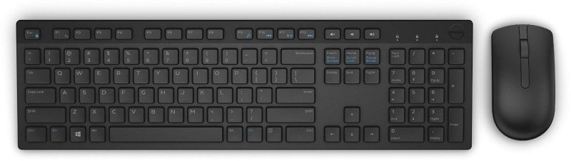

Most keyboards used in today’s workspaces use the QWERTY keyboard layout. This layout was first invented by Christopher Latham Sholes in 1868. Its design allows popular key combinations to be made more efficiently. Today’s keyboards contain many more keys than Sholes’ original design, however. At the top of the keyboard, you see the function row (the keys labeled F1, F2, F3…). These keys have functions specific to the program or window you are in, but are often not necessary for causal keyboard use.

The main portion of the keyboard holds the QWERTY keyboard, along with a number row above it and different useful keys on the sides. The keys on either side of the QWERTY keyboard are often used while typing. Here are a few examples of what these keys do:

***Please refer to the pages 5-7 if you have trouble finding these keys***

* **Backspace:** Deletes anything behind the I-beam (flashing symbol on a text document that looks like this |). Clicking it once will delete one letter, character or space and holding it down will continuously delete. *Note: there is a Delete key to the side of the Backspace key. The Delete key removes everything to the right of the I-beam.
* **Enter:** Enter can be used for going to websites, submitting information or creating ‘hard-returns’ on a word document.
* **Caps Lock:** Caps Lock, when clicked, will cause all of the keys to be upper case LIKE THIS. All the keys will remain upper case until Caps Lock is clicked again.
* **Tab:** Tab can be used to make an indent on a word document or as a way to easily jump from word box to word box when entering in information via an online form such as a job application.
* **Shift:** The Shift key is on either side of the keyboard. Both keys serve the same function. The shift key is what is known as a modifier key. Holding the shift key in junction with another key will perform a certain action based on the second key you are pressing.
  + For example: Pressing Shift + a = A on the screen

Some keys will have two symbols on them, like the number keys, with one symbol at the bottom of the key and one at the top. Pressing shift plus one of these keys will produce the symbol at the top of the key.

* + For example: Pressing Shift + 5 = % on the screen
* **Ctrl, Fn, Alt:** These keys are modifier keys like the shift key, however, they serve different purposes not just relating to the keyboard. Some functions are universally applicable to the majority of computers like Ctrl + C, which will copy a highlighted text or image when clicked. Please refer to the Basic PC shortcut keys packet for further information regarding these keys.

Now that we know a bit more about the keyboard, let’s try using it.

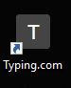Use the shortcut for <https://www.typing.com/> on the desktop. It will look like this:

Once you arrive at the website, click the yellow box entitles, “Typing Lessons” toward the middle of the page. This will take you to a few introductory typing lessons. Use this time to go through these at your own pace.

Be sure to create an account in order to save your progress and practice at home!

For more computer literacy classes, check the public calendar for the Word 1 and Excel 1 workshops.



Backspace



Enter



Caps Lock



Tab



Shift



Ctrl or “Control”



Fn or “Function”



Alt (pronounced as is) or “Alternate”